 | Name | ID
1 | Sohaila Mahfouz Mohamed | 2401411
2 | Radwa Walid Ali | 2401446
3 | Amany Ayman Emara | 2401385
4 | Yusuf Maher Elsrougy | 2401247

Beauty Clinic
Website
Phase 2: System Analysis & Design

Prepared by:

Instructor:
Dr. Sahar El Kazzaz
Eng. Esraa Ahmed

Academic Year:
2025 – 2026

C o n t e n t s
Table of Contents

01 Stakeholders & Actors
User and Admin identification

02 System Requirements
Functional & Non-functional

03 Use Case Diagram
UML actors and use cases

04 Use Case Description
Book Appointment detailed flow

05 Sequence Diagram
Book Appointment interaction

06 Activity Diagram
Booking process flow

07 Class Diagram
System classes & relationships

08 System Architecture
3-tier architecture
09 ERD
Entity Relationship Diagram

10 Database Schema
Database Schema (Tables, Attributes, Relationships)

S y s t e M A n a l y s i s
01 Stakeholders & Actors
The Beauty Clinic Website system has two primary actors who interact with the system in distinct roles. Each actor has a defined set of responsibilities and system access privileges.
User (Client)
Registered or guest client who visits the website
- Register / Login to the system
- Browse available services
- View clinic specialists
- Book appointments
- View booking status and history
- Browse skincare products
- Place product orders
- Send messages to the clinic
- View before & after gallery

Admin
Clinic staff member with full system management access
- Manage services (Add / Edit / Delete)
- Manage specialists profiles
- Manage skincare products
- View all booking requests
- Approve or reject bookings
- View client messages
- Monitor dashboard statistics
- Manage gallery content

S y s t e M A n a l y s i s
02 System Requirements
Functional Requirements
ID | Requirement | Actor | Priority
FR-01 | The system shall allow users to register and log in using email and password. | User | High
FR-02 | The system shall display all available clinic services with name, price, and duration. | User | High
FR-03 | The system shall allow users to view specialist profiles. | User | Medium
FR-04 | The system shall allow logged-in users to book an appointment by selecting service, specialist, date, and time. | User | High
FR-05 | The system shall save new bookings with status "Pending" until reviewed by admin. | System | High
FR-06 | The system shall allow admin to approve or reject appointment requests. | Admin | High
FR-07 | The system shall notify users of booking status changes. | System | Medium
FR-08 | The system shall allow users to browse and purchase skincare products. | User | Medium
FR-09 | The system shall allow users to send contact messages to the clinic. | User | Medium
FR-10 | The admin shall be able to manage services, specialists, and products (CRUD). | Admin | High
FR-11 | The system shall display a before & after gallery of treatment results. | User | Low

Non-Functional Requirements
ID | Category | Requirement
NFR-01 | Performance | Pages must load within 3 seconds under normal conditions.
NFR-02 | Usability | The system interface must be easy to navigate for non-technical users.
NFR-03 | Security | User passwords must be hashed before storage. Sessions must be authenticated.
NFR-04 | Reliability | The system must maintain data integrity; no booking data should be lost.
NFR-05 | Scalability | The database design must support growth in users and bookings over time.
NFR-06 | Compatibility | The website must be responsive and functional on mobile, tablet, and desktop.
NFR-07 | Maintainability | Code must be modular and well-commented for ease of future updates.

S y s t e M D e s i g n
03 Use Case Diagram
The following Use Case Diagram illustrates all interactions between the two primary actors (User and Admin) and the Beauty Clinic Website system.
UML Use Case Diagram — Beauty Clinic Web site
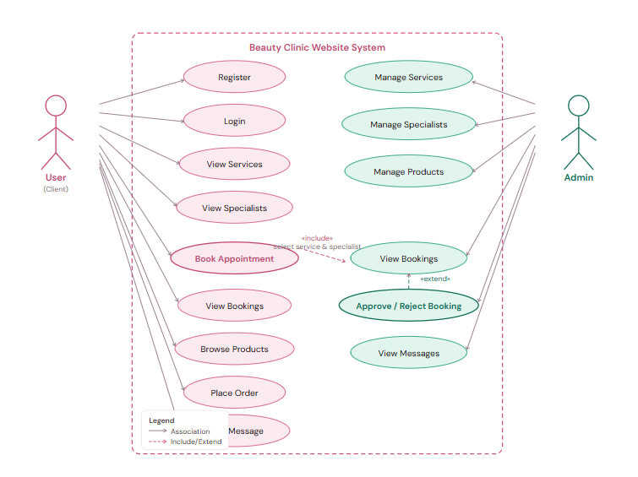

S y s t e M D e s i g n

04 Use Case Description
The following is a detailed description of the most critical use case in the system: Book Appointment.

Use Case Name | Book Appointment
Use Case ID | UC-05
Actor | User (Client)
Description | Allow a registered and logged-in user to submit an appointment request by selecting a service, a specialist, a preferred date, and a time slot. The request is saved as “Pending” until an admin reviews and confirms or rejects it.
Preconditions | • The user is registered in the system.  • The user is logged in.  • At least one service and one specialist are available in the system.
Main Flow | 1. The user navigates to the “Book Appointment” page.  2. The system displays a booking form with available services.  3. The user selects a service from the dropdown list.  4. The system updates the form to show available specialists for the chosen service.  5. The user selects a specialist.  6. The user selects a preferred date from the date picker.  7. The user selects a preferred time slot.  8. The user clicks the “Submit Booking” button.  9. The system validates all fields are filled.  10. The system saves the booking record in the database with status = “Pending”.  11. The system displays a confirmation message to the user: “Your appointment request has been submitted successfully.”  12. The admin is notified of the new pending request in the dashboard.
Alternative Flow  (Admin Rejects) | - After step 12, the admin reviews the booking request in the Admin Dashboard.  - The admin selects “Reject” for the booking.  - The system updates the booking status to “Rejected”.  - The system notifies the user that their appointment request was rejected.  - The user may submit a new booking request with different details.
Alternative Flow  (Validation Error) | At step 9, if any field is empty or invalid, the system displays an error message.  The system highlights the missing or invalid fields.  The use case returns to step 3 for the user to correct the input.
Postconditions | • A new booking record exists in the database with status “Pending”, “Confirmed”, or “Rejected”.  • The user can view their booking in “My Bookings” page.  • The admin can see the request in the Admin Dashboard.

S y s t e M D e s i g n
05 Sequence Diagram — Book Appointment
This sequence diagram illustrates the interaction between objects during the "Book Appointment" use case, from the moment the user selects a service to the admin's approval or rejection.

Sequence Diagram — Book Appointment

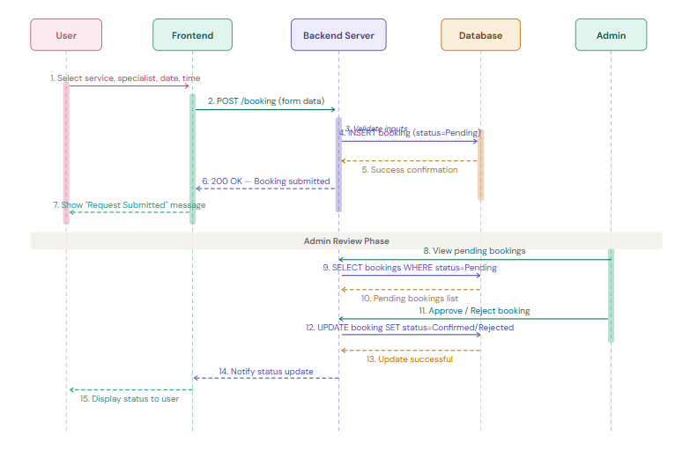

S y s t e M D e s i g n
06 Activity Diagram — Booking Process
The activity diagram below shows the complete flow of the booking process, including the admin decision point with branches for approval and rejection.

Activity Diagram — Book Appointment

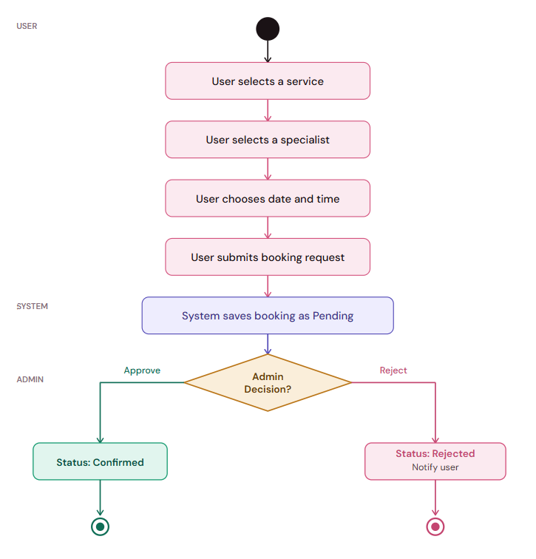

S y s t e M D e s i g n
07 Class Diagram
The class diagram shows the main system classes, their attributes, and the relationships (associations and multiplicities) between them.

UML Class Diagram — Beauty Clinic Website

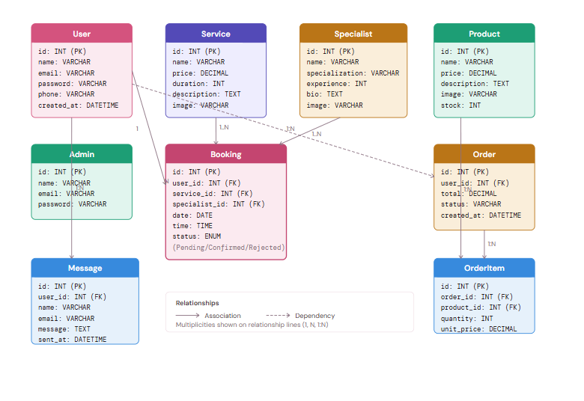

S y s t e M D e s i g n
08 High-Level System Architecture
The Beauty Clinic Website follows a classic 3-Tier Architecture, separating the presentation, logic, and data layers. This ensures modularity, maintainability, and scalability.

tiera 1 — PRESENTATION LAYER
Frontend (Client Side)
HTML5 | CSS3 | JavaScript | Bootstrap | Responsive UI | Admin Dashboard

Handles all user-facing pages: Home, Services, Specialists, Booking, Gallery, Products, Contact. The Admin Dashboard is a protected frontend section accessible only to authenticated admins.
↕
TIER 2 — APPLICATION LAYER
Backend Server (PHP)
PHP | Session Management | Authentication | Booking Logic | Order Processing | Admin API

Processes all business logic: validates input, manages sessions, handles booking workflows, enforces role-based access control, and acts as intermediary between frontend and database.
↕
TIER 3 — DATA LAYER
Database (MySQL)
MySQL | Users Table | Bookings Table | Services Table | Products Table | Orders Table | Messages Table

Stores and manages all persistent data. The database enforces referential integrity via foreign key constraints and uses ENUM types for booking statuses.

S y s t e M D e s i g n
09 Entity Relationship Diagram (ERD)
The ERD shows all database entities, their primary keys, foreign key relationships, and cardinalities. All relationships are 1:N (one-to-many).
ERD — Beauty Clinic Website Database

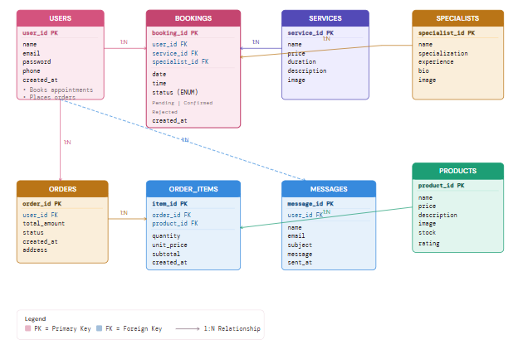

S y s t e M D e s i g n
09 Database Schema
The data dictionary provides a field-level description of every attribute in the database, including data type, constraints, and purpose.

د
Users:

FIELD | TYPE | CONSTRAINTS | DESCRIPTION
user_id PK | INT | AUTO_INCREMENT, NOT NULL | Unique identifier for each registered user
name | VARCHAR(100) | NOT NULL | Full name of the user
email | VARCHAR(150) | NOT NULL, UNIQUE | Email address used for login and communication
password | VARCHAR(255) | NOT NULL | Hashed password for authentication
phone | VARCHAR(20) | Nullable | Optional contact phone number
created_at | DATETIME | DEFAULT NOW() | Timestamp of account creation

Services:

FIELD | TYPE | CONSTRAINTS | DESCRIPTION
service_id PK | INT | AUTO_INCREMENT | Unique identifier for each clinic service
name | VARCHAR(100) | NOT NULL | Name of the beauty treatment (e.g., Botox, Laser)
price | DECIMAL(10,2) | NOT NULL | Service price in USD
duration | INT | Nullable | Session duration in minutes
description | TEXT | Nullable | Detailed description of the treatment
image | VARCHAR(255) | Nullable | Path to service image file

Specialists:

FIELD | TYPE | CONSTRAINTS | DESCRIPTION
specialist_id PK | INT | AUTO_INCREMENT | Unique identifier for each doctor or specialist
name | VARCHAR(100) | NOT NULL | Full name of the specialist
specialization | VARCHAR(100) | Nullable | Area of medical expertise
experience | INT | Nullable | Years of professional experience
bio | TEXT | Nullable | Professional biography shown on the Specialists page
image | VARCHAR(255) | Nullable | Path to specialist profile photo

Bookings:

FIELD | TYPE | CONSTRAINTS | DESCRIPTION
booking_id PK | INT | AUTO_INCREMENT | Unique identifier for each appointment request
user_id FK | INT | NOT NULL → users | References the user who made the booking
service_id FK | INT | NOT NULL → services | References the selected service
specialist_id FK | INT | NOT NULL → specialists | References the selected specialist/doctor
date | DATE | NOT NULL | Requested appointment date
time | TIME | NOT NULL | Requested appointment time slot
status | ENUM | DEFAULT 'Pending' | Booking lifecycle state: Pending, Confirmed, or Rejected
created_at | DATETIME | DEFAULT NOW() | Timestamp when the booking was submitted

Products:

FIELD | TYPE | CONSTRAINTS | DESCRIPTION
product_id PK | INT | AUTO_INCREMENT | Unique identifier for each skincare product
name | VARCHAR(100) | NOT NULL | Product name (e.g., Vitamin C Serum, Sunscreen)
price | DECIMAL(10,2) | NOT NULL | Product sale price in USD
description | TEXT | Nullable | Product description and ingredients
image | VARCHAR(255) | Nullable | Path to product image file
stock | INT | DEFAULT 0 | Available inventory quantity
rating | DECIMAL(2,1) | DEFAULT 0.0 | Average customer rating (0.0 – 5.0)

Orders:

FIELD | TYPE | CONSTRAINTS | DESCRIPTION
order_id PK | INT | AUTO_INCREMENT | Unique identifier for each customer order
user_id FK | INT | NOT NULL → users | References the user who placed the order
total_amount | DECIMAL(10,2) | NOT NULL | Total price of all items in the order
status | VARCHAR(50) | DEFAULT 'Pending' | Order fulfillment status (Pending, Shipped, Delivered)
address | TEXT | Nullable | Shipping/delivery address
created_at | DATETIME | DEFAULT NOW() | Timestamp when the order was placed

order_items:

FIELD | TYPE | CONSTRAINTS | DESCRIPTION
item_id PK | INT | AUTO_INCREMENT | Unique identifier for each line item
order_id FK | INT | NOT NULL → orders | References the parent order
product_id FK | INT | NOT NULL → products | References the purchased product
quantity | INT | NOT NULL, DEFAULT 1 | Number of units ordered
unit_price | DECIMAL(10,2) | NOT NULL | Price per unit at time of purchase (snapshot)
subtotal | DECIMAL(10,2) | GENERATED (quantity * unit_price) | Computed total cost for this line item

Messages:

FIELD | TYPE | CONSTRAINTS | DESCRIPTION
message_id PK | INT | AUTO_INCREMENT | Unique identifier for each contact message
user_id FK | INT | Nullable → users | References registered user; NULL for guest messages
name | VARCHAR(100) | NOT NULL | Sender's full name (from contact form)
email | VARCHAR(150) | NOT NULL | Sender's email address for reply
subject | VARCHAR(200) | Nullable | Message subject line
message | TEXT | NOT NULL | Full message body text
sent_at | DATETIME | DEFAULT NOW() | Timestamp when the message was submitted
is_read | TINYINT(1) | DEFAULT 0 | Admin read status: 0 = unread, 1 = read

